ANGELO MARASIGAN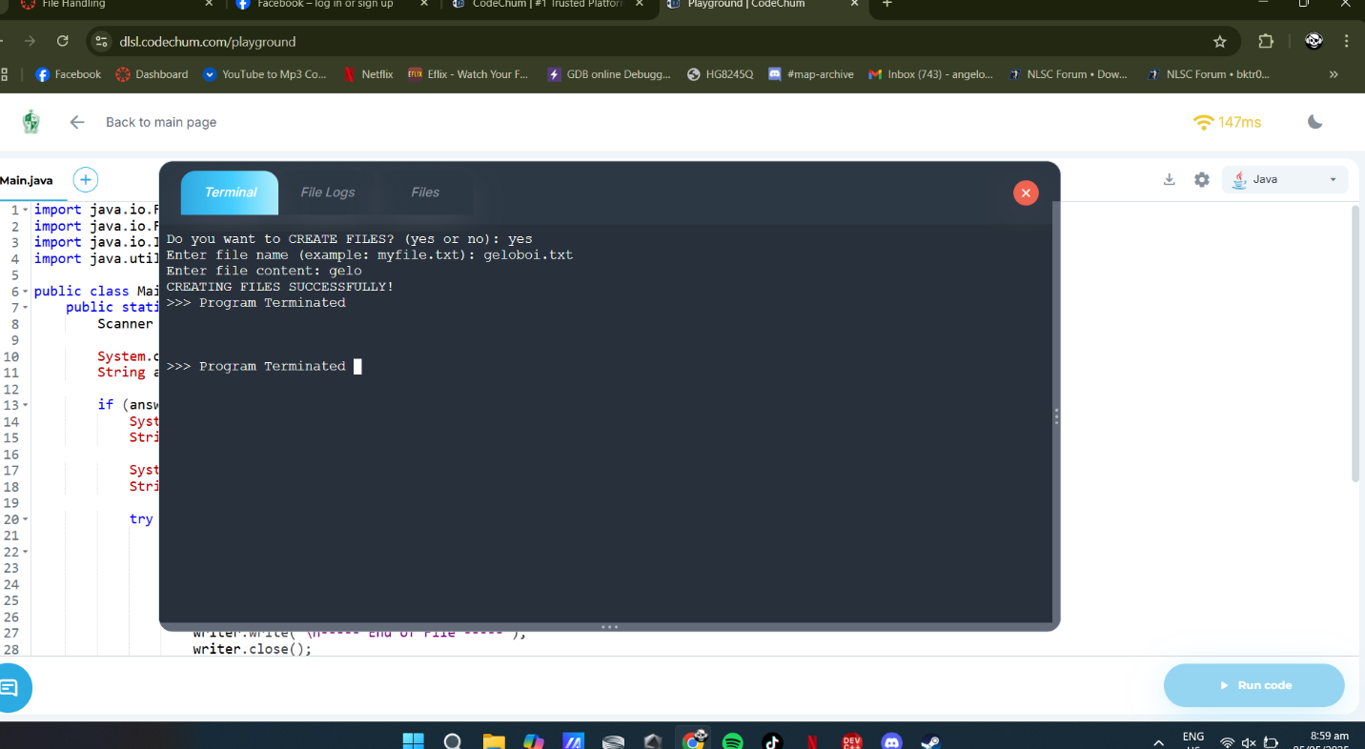

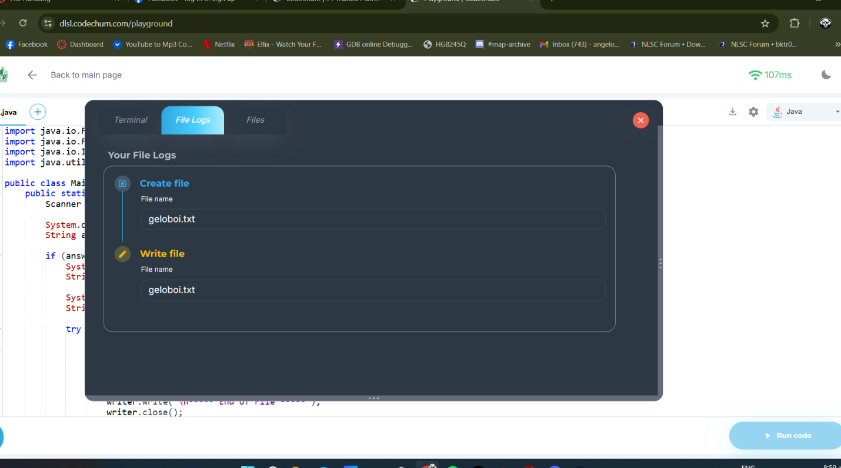

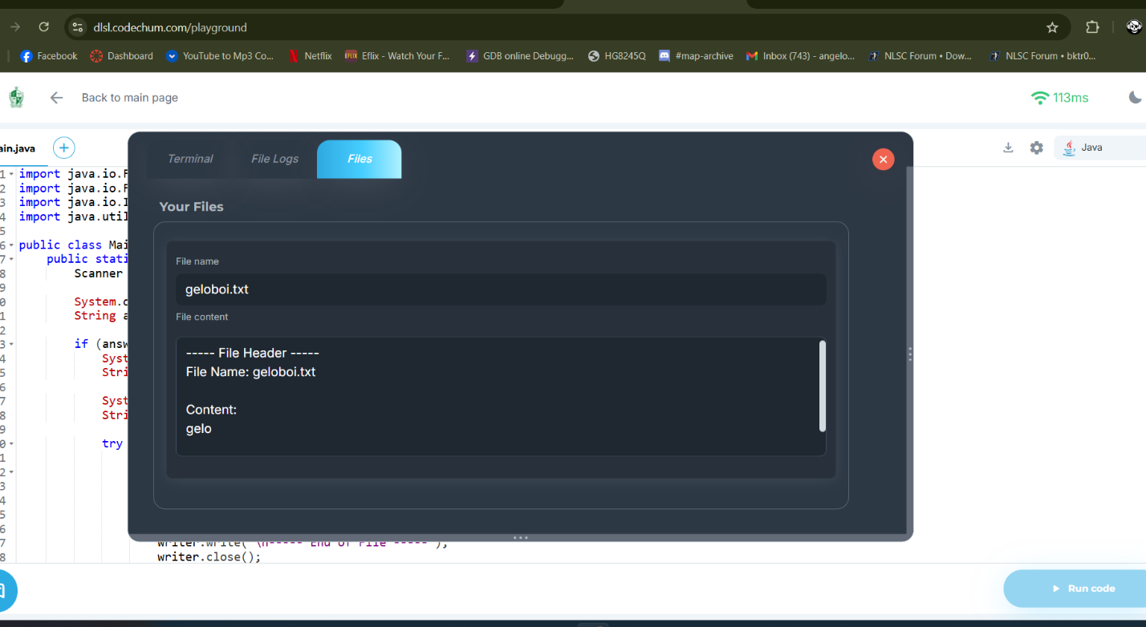

MY CODE

import java.io.File;

import java.io.FileWriter;

import java.io.IOException;

import java.util.Scanner;

public class Main {

public static void main(String[] args) {

Scanner input = new Scanner(System.in);

System.out.print("Do you want to CREATE FILES? (yes or no): ");

String answer = input.nextLine().trim().toLowerCase();

if (answer.equals("yes")) {

System.out.print("Enter file name (example: myfile.txt): ");

String fileName = input.nextLine();

System.out.print("Enter file content: ");

String content = input.nextLine();

try {

File file = new File(fileName);

if (file.createNewFile()) {

FileWriter writer = new FileWriter(fileName);

writer.write("----- File Header -----\n");

writer.write("File Name: " + fileName + "\n\n");

writer.write("Content:\n" + content + "\n");

writer.write("\n----- End of File -----");

writer.close();

System.out.println("CREATING FILES SUCCESSFULLY!");

} else {

System.out.println("File already exists. Cannot overwrite.");

}

} catch (IOException e) {

System.out.println("An error occurred while creating the file.");

e.printStackTrace();

}

} else {

System.out.println("File creation canceled.");

}

System.out.println(">>> Program Terminated");

}

}